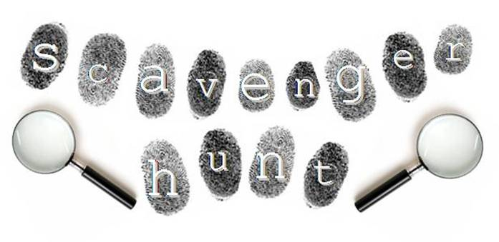
Health Science
Fall 2013
Unit 1 Leadership

Directions:
- Brainstorm a list of items that you think would be beneficial for the classroom. They may be normal supplies we use everyday, to things that you think would be helpful for future presentations, projects, skits, holidays, etc.
- Discuss with your group what items you think are ESSENTIAL (aka things we will use all the time, or things we could potentially run out of throughout the year).
- Construct your list of 26 items that YOUR TEAM will collect throughout the week (these may be items that are brand new, or gently used… think RECYCLE!!!)
- BRING THE ITEMS TO CLASS. You will need to track them with your group each day, taking note of what you’re still missing. I will collect items daily.
- ALL ITEMS ARE DUE { }. The team who collects the MOST items on their list will receive a prize. If there is a tie with groups collecting ALL of the 26 items, you will ALL get the prize. I guarantee YOU WILL WANT THE PRIZE :)
ULTIMATE GOAL???? Find 26 different items in the allotted time, each beginning with a different letter of the alphabet. Be sure to have a bag with you to collect your items in. The idea is that we all share in the responsibility of getting the items we need to be successful. It is not the QUANTITY of the items you bring, but the QUALITY of your teamwork to figure out ways to get the items on your list so that your team as a whole is successful. Good luck!!!
A | B | C | D | E | F
G | H | I | J | K | L
M | N | O | P | Q | R
S | T | U | V | W | X
Y | Z | BONUS | BONUS | BONUS | BONUS

